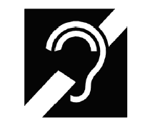
I AM HARD OF HEARING

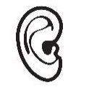
PLEASE:
GET MY ATTENTION
FACE ME
SPEAK A LITTLE SLOWER
_____________________________________________________________________

